Prototyping for the Accelerometer

Derrian Glynn

ECEN4013

October 20, 2015

## Flowchart of I/O

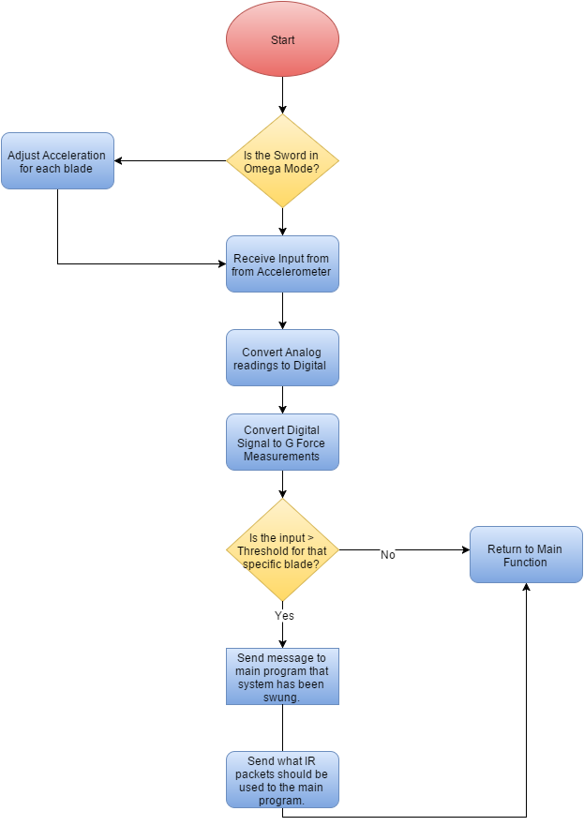

## Expected input and Output

### Hardware Input

|  |  |  |
| --- | --- | --- |
| **Name** | **Description** | **Expected Value** |
| X Force | The Acceleration force acted on the blade is respect to the X-Axis of the Accelerometer. | 0 to 3 V |
| Y Force | The Acceleration force acted on the blade is respect to the Y-Axis of the Accelerometer. | 0 to 3 V |

### Software Functions

|  |  |  |  |
| --- | --- | --- | --- |
| **Name** | **Description** | **Inputs** | **Outputs** |
| Init_accel | Initialize any registers, peripherals, etc. needed for the accelerometer functions. | N/A | N/A |
| determine_sword_was_swung | Sets up RA4 as an interrupt-on-change pin, and initializes a timer for measurements. | X-Axis, Y-Axis | High Bit for swung |
| IR Packets | Determines the length of the data pulse and determines what type of packet was received. | Swung reading | Message to read LEDs |

### Hardware Output

|  |  |  |
| --- | --- | --- |
| **Name** | **Description** | **Expected Results** |
| X Out | Voltage for X force Detected. | Voltage sent to Microcontroller. |
| Y Out | Voltage for Y force Detected. | Voltage sent to Microcontroller. |

### Software Output

|  |  |  |
| --- | --- | --- |
| **Name** | **Description** | **Expected Values** |
| Swung | High bit to indicate that the sword has been swung for the correct acceleration. |  |
| IR_Packets | Modified counter to determine the length of a stun. | Previous value, or previous value +1 |